Biomes Exam

Multiple Choice
Identify the letter of the choice that best completes the statement or answers the question.

____ 1. The specific environment of the ecosystem in which an organism lives is the organism's

____ 2. An organism that can make its own food is called a

____ 3. Which of these consumers is an herbivore?

____ 4. Vultures, which feed on the bodies of dead organisms, are

____ 5. The first organism in a food chain is always a(n)

____ 6. If a kestrel eats a mouse that eats grass, the kestrel is a(n)

____ 7. A diagram that shows the amount of energy that moves from one feeding level to another in a food web is called a(n)

____ 8. In an energy pyramid, which level has the most available energy?

____ 9. The amount of energy that is transferred from one level of a food web to the next higher level is about

____ 10. The typical weather pattern in an area over a long period of time is called

____ 11. Because similar climates exist on different continents, the antelope of Africa occupy the same niche as the

____ 12. A group of ecosystems with similar climates and organisms is called a(n)

____ 13. Which land biome receives less than 25 centimeters of rain per year?

____ 14. Which land biome is extremely cold and dry?

____ 15. A canopy, an understory, and an extremely high number of plant and animal species are characteristics of which biome?

____ 16. Ponds and rivers are two types of

____ 17. In a Rain Forest Biome which of the following would be at the producer level

____ 18. Given what you know of Rain Forest Biomes which conclusion is most likely true
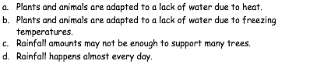

____ 19. Given what you know of Grassland Biomes which conclusion is most likely true

____ 20. Given what you know of Tundra Biomes which conclusion is most likely true

____ 21. The combined portions of Earth in which all living things exist is called the
a. biome. b. community. c. ecosystem. d. biosphere.

____22. All of the members of a particular species that live in one area are called a(an)
a. biome. b. population. c. community. d. ecosystem.

____ 23. Green plants are
a. producers. b. consumers. c. herbivores. d. omnivores.

____ 24. What is the original source of almost all the energy in most ecosystems?
a. carbohydrates b. sunlight c. water d. carbon
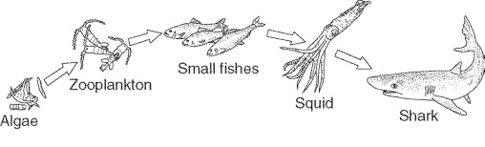Figure 3-1

____ 25. The algae at the beginning of the food chain in Figure 3-1 are
a. consumers. b. decomposers. c. producers. d. heterotrophs.

____ 26. An organism that uses energy to produce its own food supply from inorganic compounds is called a(an)
a. heterotroph. b. consumer. c. detritivore. d. autotroph.

____ 27. An organism that cannot make its own food is called a(an)
a. heterotroph. b. chemotroph. c. autotroph. d. producer.

____ 28. All the interconnected feeding relationships in an ecosystem make up a food
- interaction. b. chain. c. network. d. web

-------- 29. Permafrost is a condition found in
- the tundra b. the desert c. the taiga d. deciduous forests
-------30. The most common forms of plant life in the tundra are
- pine trees b. oak trees c. mosses and lichens d. fruit-bearing trees
-------31. The taiga is characterized by
a. pine trees b. the polar bear c. trees that lose their leaves d. small shrubs

-------32. Maples, beeches, and elms would most likely be found in the
a. tundra b. taiga c. coniferous forest d. deciduous forest

